Light

Lesson #3: Reflecting Light: Periscopes

Talk with your classroom teacher about allowing students to play with and familiarize themselves with mirrors before this lesson, especially the use of 2 or more mirrors together. Students should be prepared to share their observations about mirrors with the class. Also, ask Jen or Molly for periscope kits to test them out yourselves 1 week before this lesson.

Time Frame: 60 minutes
Please write the vocabulary on the board before each lesson.

Vocabulary
Angle of incidence - the angle at which a ray of light strikes a mirror
Angle of reflection - the angle at which a ray of light leaves a mirror
Reflection - when light hits a surface and bounces back

Learning Standards:
Science
Science and Engineering Practices
- Develop a model to describe phenomena.
Crosscutting Concepts
- Cause and effect relationships are routinely identified.
Engineering
Engineering Design
- Testing a solution involves investigating how well it performs under a range of likely conditions.

Student will be able to:
- Identify the angle of incidence and angle of reflection.
- Explain the equivalence of the angle of incidence and angle of reflection.
- Explain how a periscope works using the idea of reflecting light.

Resources and Materials:
Item | Amount
Science Journals
Periscope kits | 25 (in bin)
Mirrors | 2 (in bin)
Tape | 2 rolls (in bin)
Glue | (in classroom)
Protractor | 1 (in bin)
Writing utensils | (in classroom)
White paper | (in classroom)
Crayons or markers | (in classroom)
Pre-made periscopes* | 1-2 (made yourselves)
*Ask Jen or Molly for periscope kits to try it yourself 1 week before this lesson.
Focus Activity: Demonstrate the periscope you constructed before class to show students how periscopes work. Have one teacher stand where he/she cannot see the other teacher. Using the periscope, show the class that you can read a sign or answer a question written by the other teacher even though your vision should be obstructed. Ask students to write a hypothesis in their science journals about what just happened and how the demonstrator was able to see "through" the obstacle. Show students the periscope and let them look through it if they are interested.

Introduction: Talk to students about what they observed while playing with mirrors. Ask if anyone noticed anything special about reflections. Demonstrate the angle of incidence and angle of reflection using a mirror, a piece of paper, a writing utensil, and a protractor. Draw a vertical dotted line on the paper (See Figure 10-1). Draw a darker line at an angle, going through the dotted line (See Figure 10-2). Put a small rectangular mirror perpendicular to the dotted line (See Figure 10-3). Draw the reflected line on the other side of the dotted line from the original line, starting from the point where the dotted line, original dark line, and mirror meet (See Figure 10-4). Measure the angles between the dotted line and the two darker lines (See Figure 10-5). They should be equal. With a flat mirror, this will always be true. Explain that the darker lines you drew are models for light; when light hits a mirror, it will reflect from the mirror at the same angle that it hit the mirror. This is how mirrors work; the images you see in mirrors are not the things themselves, but rather reflections. Light rays first reflect off of the object from the light source and travel to the mirror. They are reflected from the mirror and travel back to the eye, where we can then register the image. Thus, without reflected light from a light source, we are unable to see things.

Activity:
- Connect the idea of reflecting light to mechanical designs. People make use of the reflective quality of light. Because a ray of light will leave a mirror at the same angle that it hits it, we are able to redirect light rays around or "through" obstacles. This is what a periscope does. Write the word periscope on the board.
- Draw an image of the inside of a periscope, showing the position of the two mirrors. Feel free to draw an obstacle for the periscope to be seeing around as well. Using a colored marker, draw a line to model the path of a ray of light traveling through the periscope, hitting the two mirrors and reflecting off of them to arrive at the eyehole at the bottom of the periscope. Explain that this is how the periscope allows people to see around or "through" an obstacle by bending or reflecting light from one place to another that it normally would not travel through, since light normally travels in straight lines. If done correctly, the line of light entering the periscope should be parallel to the line of light leaving the periscope.
- Give students a minute to play with mirrors to explore their effects on light.
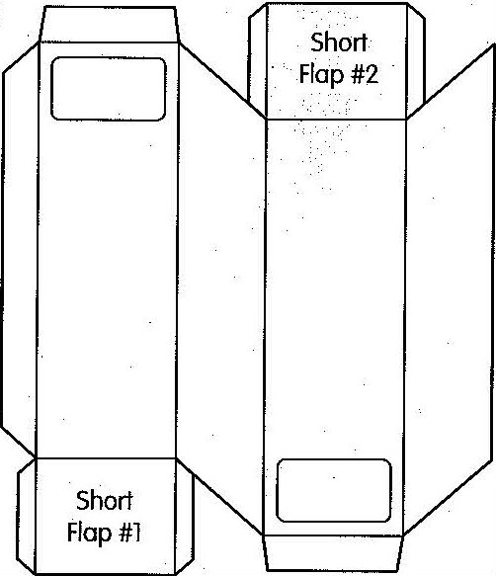
- Construct the periscopes. Lay the periscope flat on the table, white side facing down. Remove the self-adhesive backing from two mirrors and position them on the brown side of the short flaps (labeled as short flap #1 and short flap #2 in the illustration). Press the mirrors down firmly. To be safe, tape or glue down the mirrors.
- To assemble the body of the periscope, fold the cardboard along the scored lines, keeping the white side of the cardboard on the outside, and tape the sides together. Tuck in the side flaps on the sides of the short flaps and tape closed.
- Test the periscopes.
- If time allows, students may decide to color their periscopes using crayons or markers (not included in bins) before gluing on the camouflage leaves. Punch out the leaves from the sheet, apply glue to the white side and place them on the periscope.
Closure: Write in your science notebook: How does a periscope allow us to extend our line of vision? What other tools can you think of that allow you to see things you couldn’t see with just your eyes?

Assessment: science notebooks, participation

