Waves

Lesson #2: Types of Waves

Consult with your classroom teacher to make sure parallel and perpendicular lines have already been taught in their math class.

Time Frame: 60 minutes
Please write the vocabulary on the board before each lesson.

Vocabulary
Transverse Wave - A wave that moves across a medium in a direction perpendicular to the direction in which the wave travels.
Longitudinal Wave - A wave that moves across a medium in a direction parallel to the direction in which the wave travels.

Learning Standards:
Science
Waves and their Applications in Technologies for Information Transfer
- Similarities and differences in patterns can be used to sort and classify natural phenomena.
Science and Engineering Practices
- Develop a model using an analogy, example, or abstract representation to describe a scientific principle.

Student will be able to:
- Create models of transverse and longitudinal waves.
- Conduct experiments explaining the characteristics of waves.

Resources and Materials:
Item | Amount
Science Journals
iPads
Types of Waves diagrams (overhead or make copies) | (in binder)
Rubber rope | 3 (in bin)
Slinkies | 3 (in bin)
Colored tape | 1 roll (in bin)

Focus Activity: Ask students to give some examples of mediums that carry waves. Discuss whether a duck floating on the surface of a pond would be moved horizontally (side-to-side) or vertically (up-and-down) by a passing wave in the water.

Teacher Explanation: The duck would move vertically, because the type of wave passing through the water is a transverse wave. Transverse waves move through their medium in the direction perpendicular to the direction that their wave travels in. Therefore, the duck would move up and then right back down to its original starting position. It will have suffered no net change in position.

Introduction: Review parallel and perpendicular lines to introduce the concept of transverse and longitudinal waves. Make sure to consult with your classroom teacher before doing this lesson to ensure students have learned about parallel and perpendicular lines. Explain that parallel means in two lines are in the same direction, and perpendicular means two lines cross each other at right angles. Tell students that there are two types of waves, one that moves it medium parallel to the direction it travels, and one that moves its medium perpendicular to the direction it travels. Then tell students that they will be observing models of each type of wave using slinkies and ropes.

When you make a wave on a rope, the wave moves from one end of the rope to the other, but the rope itself moves up and down or from side to side, at right angles to the direction in which the wave travels. Waves that move the medium at right angles to the direction in which the wave travels are called transverse waves. Transverse means “across”. As a transverse wave moves, the particles of the medium move across, or perpendicular to, the direction of the wave.
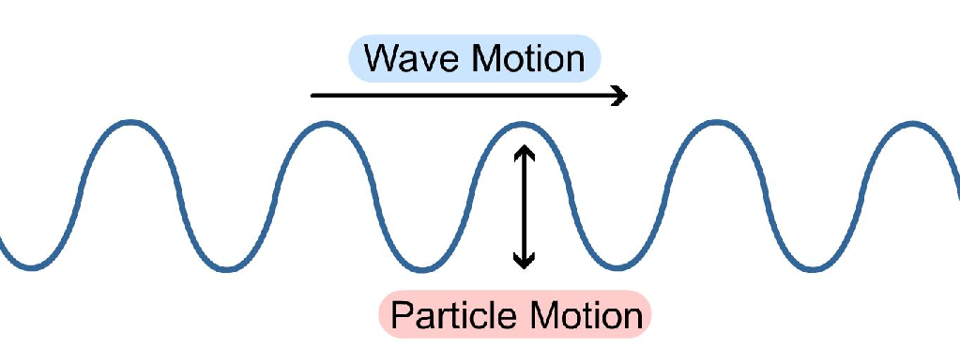

If you stretch out a slinky and push one end, the wave moves from one end to the other, and so does the slinky. The coils in the slinky move back and forth parallel to the direction in which the wave travels. Waves that move the medium parallel to the direction in which the wave travels are called longitudinal waves. Longitudinal means “lengthwise”. As a longitudinal wave moves, the particles of the medium move in the same direction as, or parallel to, the direction of the wave.
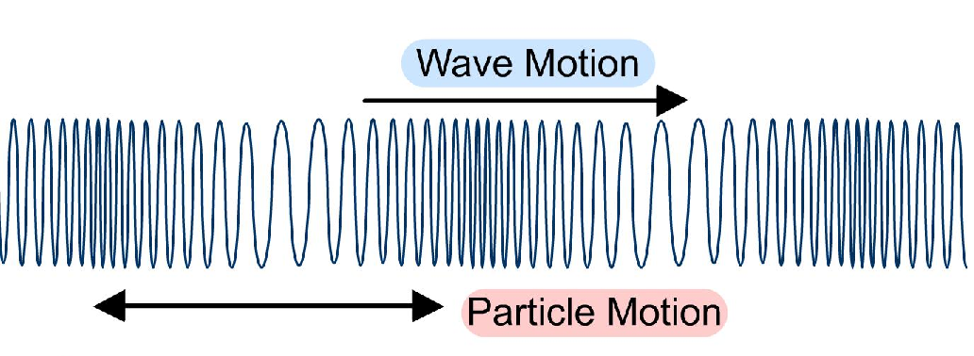
Optional Demonstration: One way to solidify student understanding of wave types is to have them act out the waves using their bodies. To demonstrate transverse waves, have the class stand in a line shoulder-to-shoulder and “do the wave” passing a wave down the line. Each student raises his or her arms as soon as the student before them in line puts their arms down. See how quickly the class can do the wave! To demonstrate longitudinal waves, have the students line up with their hands on the shoulders of the person in front of them. Have each student carefully lean into the student in front of them and then stand up straight. Each student must wait until they have been “leaned into” before they can continue the wave.

Activity: Students will use a rope and slinky to demonstrate transverse and longitudinal waves.
- Demonstrate how to create a longitudinal wave with a slinky on a flat surface such as a table or the floor so that students will be careful not to tangle their models. This will require two people to hold the slinky (one on either end). Tell students that the slinky will serve as their model for longitudinal waves.
- Demonstrate how to create a transverse wave with a rope. Instruct students to be gentle when making the waves so they can observe the differences in motion between transverse and longitudinal waves.
- Divide students into groups of 3-4, with one iPad per group. Each group will make two video models of waves: one using a slinky and one using a rope. Have students wrap a piece of tape around the middle of their model before filming.
- Two students will hold either end of the model and make a wave. A third student will videotape the wave using the app “Video Physics” on the iPad. Monitor students to ensure proper use of slinkies and ropes.
- Using Video Physics, map out the wave by marking the position of the tape in the video.
- View the results in graph form and see how the rope moved up and down perpendicular to the direction of the wave, and the slinky moved across the floor in the same direction as the wave. Write observations in science journals.

Extension Activity: (if groups finish early) Using the app “String” on the iPad, let students come up with different kinds of waves. Ask them to observe whether they are producing transverse or longitudinal waves with the app.

Closure: Discuss as a class: How do models help us explain waves? Today you saw a couple different models of waves, like the human model you did at the beginning of class, drawings of waves, and ropes and slinkys. Can you think of any other models? Think back to last class. Were any of the waves you saw transverse? How about longitudinal?

Assessment: Science notebook observations about Video Physics, participation in the activities and class discussions.

